Warrengate Medical Centre

Tel: 01924 371011 – Appointments & Enquiries

[www.warrengate.org.uk](http://www.warrengate.org.uk)

**Autumn Newsletter**



W

elcome to this issue of our Practice Newsletter. The newsletter is to provide patients with any news, information or forthcoming events. If you have any suggestions as to what you would like to see in your newsletter please inform a member of staff.

Staff Training Dates

Please make a note of the dates below when the surgery will close.

* Wednesday 16th October
* Wednesday 13th November

We will close at 12noon on the day of training and re-open the following day at 8.00am. If you need a Doctor in an emergency please telephone NHS111.

New Vaccination Programme : Respiratory Syncytial Virus (RSV) Vaccine

Are you turning 75 years old on or after the 1st September 2024? If so you are now eligible for a new vaccination as part of the new vaccination programme started in September 2024. Please see the link below which will provide you with more detail on this [RSV vaccine for adults (publishing.service.gov.uk)](https://gbr01.safelinks.protection.outlook.com/?url=https%3A%2F%2Fassets.publishing.service.gov.uk%2Fmedia%2F668eb423fc8e12ac3edafa9d%2FUKHSA_12949_RSV_vaccine_for_adults_14_WEB.pdf&data=05%7C02%7Cr.goldthorpe%40nhs.net%7C443263c8289a4efd987b08dcb6bd85c3%7C37c354b285b047f5b22207b48d774ee3%7C0%7C0%7C638586172316930560%7CUnknown%7CTWFpbGZsb3d8eyJWIjoiMC4wLjAwMDAiLCJQIjoiV2luMzIiLCJBTiI6Ik1haWwiLCJXVCI6Mn0%3D%7C0%7C%7C%7C&sdata=ubBySQW0I22TwI4DeyqKgjJvbeSkbP3G2LYnm%2BvaFAg%3D&reserved=0).

You can still get the vaccine up to the day before you turn 80, if you are interested please contact the surgery to make an appointment in one of our special RSV clinics with one of our Practice Nurses.

Our admin staff are actively recalling the eligible patients so you may receive a phone call or unique booking link to book in to our clinics.

Menopause Cafe

We currently offer drop-in sessions at Warrengate Medical Centre for ladies between the ages of 45- 55yrs that want more information on Menopause . These are held at the surgery on the 4th Wednesday of every month at 12.30 to 1.30 for approx. 60 minutes. If you would be interested in this, please contact the surgery for more information.

 Facebook Page 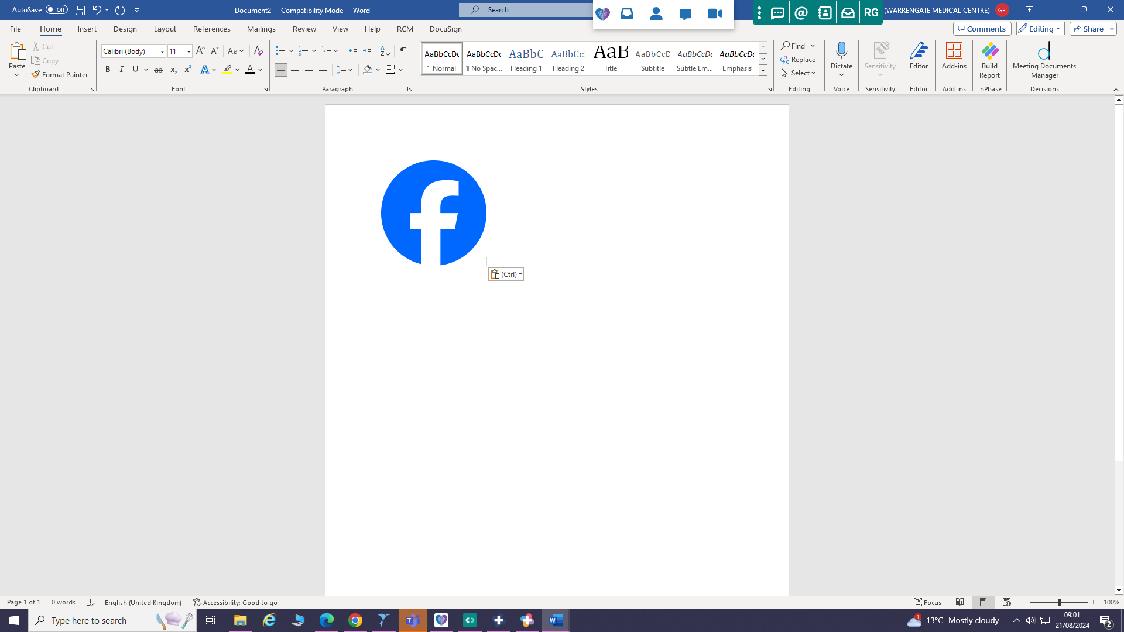

We now have a Warrengate Medical Centre Facebook page. You will find our page all about positivity, staying well and connecting patients with local organisations and groups who do amazing things to help the people here in Wakefield. On our page we will post about national and local health initiatives, providing evidence-based health advice on a range of topics. Our aim will also be to raise awareness of upcoming health campaigns whilst also sharing any Practice specific updates such as training dates, phone line issues, vaccination clinics.

Currently we have around 370 people following us but would love to see this number increase!

DNA’s

During the months of June, July and August we had 790 appointments which were not attended with doctors and nurses. If you unable to make an appointment at the surgery then please inform us so that the appointment can be cancelled and offered to another patient. In instances where patients persistently DNA their appointments after a letter has been issued highlighting this to them then patients will be removed from the Practice list and asked to register at an alternative Practice.

Just to remind patients you can cancelled appointments through the NHS App if this is more convenient than calling the Practice.

Patient Satisfaction Questionnaire

We ran an in house Practice survey from 13th November 2023 to 13th February 2024 here at Warrengate Medical Centre to gain vital feedback from our patients. A link was sent to patients after they attended an appointment with one of our clinical team.

Over 659 responses were received during that time. We had some amazing feedback, which showed that patients were only waiting less than 5 minutes for their appointments, and once in their appointments 72.7% of patients rated the clinicians excellent.

Our reception team were very highly praised as being helpful when dealing with patients. We also received some constructive feedback which we are working on improving.

Flu Vaccinations

We have now started our annual flu vaccine programme. If you are in one of the following “at risk” groups, please contact the surgery to book an appointment :

* pregnant
* aged 65 years or over
* living in a residential or nursing home
* the main carer of an older or disabled person
* a household contact of an immunocompromised person
* children of a certain age - *PLEASE ASK AT RECEPTION FOR DETAILS AS SOME AGE COHORTS ARE COVERED BY SCHOOL NURSING TEAMS*

*or* are under 65 and have / are in one of the clinical at-risk groups below :

* a heart problem
* a chest complaint or breathing difficulties, including bronchitis, emphysema, or severe asthma
* a kidney disease
* lowered immunity due to disease or treatment (such as steroid medication or cancer treatment)
* liver disease
* had a stroke or a transient ischaemic attack (TIA)
* diabetes
* a neurological condition, eg multiple sclerosis (MS), cerebral palsy or learning disability
* a problem with your spleen, eg sickle cell disease, or you have had your spleen removed
* are seriously overweight (BMI of 40 and above)

Our admin staff are actively recalling the eligible patients so you may receive a phone call or unique booking link to book in to our clinics.

If you do not wish to receive the flu vaccination then please do inform us as we will decline this on your record and then no further invites will be sent to you this year. The decline does only take you out of recall for the current flu season so you will remain eligible again for next year.

Period Poverty

Currently 24% of people who menstruate have struggled to afford period products in the last year, increasing to 27% of 18–24-year-olds. 49% of girls have missed school because of their period. Period poverty is a project which involves stations within Practices which provide free sanitary products for anyone that needs them.

You will notice we have our sanitary products station up and running in reception, these products are available for patients who may struggle to afford these ordinarily.

This is volunteer run with donations of products welcomed. If you would like to donate to this then please let one of the reception team know.

|  |
| --- |
| New Mental Health Service  111 now offers mental health support to those in crisis. To access this new element to their service any individual experiencing mental health crisis should call 111 and select option 2. It is available for anyone affected either themself or those concerned and is open to all ages (including children). |

ARRs

We would like to introduce to you the different staff members we have in surgery and how they are here to help you.

This newsletter features Claire our in-house Care Coordinator.

*“Hi my name is Claire and I am the Care Co-ordinator based here at Warrengate. I support all dementia and learning disability patients, alongside their families and carers here at the surgery.*

*I also support patients with non-medical needs and help connect them to local services and activities. The kinds of things I am able to support with are ; loneliness, support in the home, employment, attending appointments, bereavement, filling in forms or anything else that is effecting physical or mental health.*

*Patients can be referred to me by the Practice team or patients can ask for me to contact them if they feel they have a non-medical need which I may be able to help with. Patients should contact reception in the first instance and a message will be passed on to me with your contact you”*

Winter Newsletter

The Winter Newsletter will be issued in December 2024/January 2025

Please let us know if there is any information you would find useful or if you would like to know more about our services.