Warrengate Medical Centre
Tel: 01924 371011 – Appointments & Enquiries
Spring Newsletter


Welcome to this issue of our Practice Newsletter. The newsletter is to provide patients with any news, information or forthcoming events. If you have any suggestions as to what you would like to see in your newsletter, please inform a member of staff.

Staff Training Days
Please make a note of the dates below when the surgery will close.
 Wednesday 19th March

Wednesday 14th May

We will close at 12noon on the day of training and re-open the following day at 8.00am. If you need a Doctor in an emergency, please telephone NHS111.

Spring into summer!
Clocks go forward by 1 hour on Sunday 30th March 2025.

Bank Holiday Dates
Please make a note of the dates below of our opening times over the Easter and May bank holidays. If you need a doctor in an emergency please telephone NHS 111.

Friday 18th April Closed Good Friday
Saturday 19th April Closed
Sunday 20th April Closed
Monday 21st April Closed Easter Monday
Tuesday 22nd April Open as normal
Monday 5th May Closed May Day
Monday 26th May Closed Spring Bank Holiday

Yoga4health Sessions

We will be offering yoga sessions for patients starting September, there is limited places so please contact the surgery if you are interested.

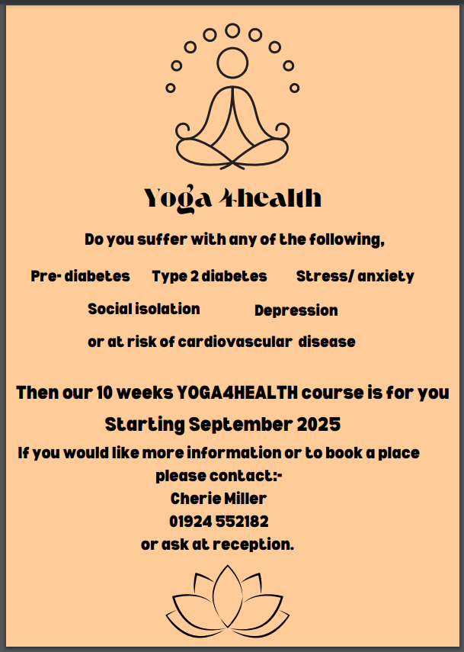

Missed Appointments
During the months of December, January and February a total of 725 patients failed to attend their appointment. Please telephone the surgery if you are unable to attend your appointment then the appointment can be used for someone else who needs it.

Smears
As a Practice, Warrengate Surgery is happy to support the nationwide NHS campaign in March to increase the amount of women having their smear test.

The NHS Cervical Screening Programme has made a significant impact on cervical cancer mortality since it was established in 1988, saving an estimated 5,000 lives a year; however, coverage is unfortunately at a 20-year low.

Please don’t ignore your cervical screening invite. If you’ve missed your last cervical screening, book an appointment now.

If you feel anxious or scared, try to remember that our nurses are very experienced at taking samples. They can talk you through ways to make the test easier. Your nurse will have done many tests before and won’t care what underwear you are wearing, what your body shape is or about your sexual history. Their focus is on taking the sample and making sure you feel at ease.

If you feel able, talk to your Nurse or GP to explain how you are feeling. It may be helpful to book an appointment with one of our Nurses beforehand to talk through what will happen at the test and ways they can make you feel more at ease. Ask as many questions as you need and make sure you are fully aware of what is going to happen during the test and after.

New Vaccination Programme: Respiratory Syncytial Virus (RSV) Vaccine
Are you turning 75 years old on or after the 1st September 2024? If so, you are now eligible for a new vaccination as part of the new vaccination programme started in September 2024. Please see the link below which will provide you with more detail on this RSV vaccine for adults (publishing.service.gov.uk).
You can still get the vaccine up to the day before you turn 80, if you are interested please contact the surgery to make an appointment in one of our special RSV clinics with one of our Practice Nurses.
Our admin staff are actively recalling the eligible patients so you may receive a phone call or unique booking link to book into our clinics.

Wellness Walking Groups

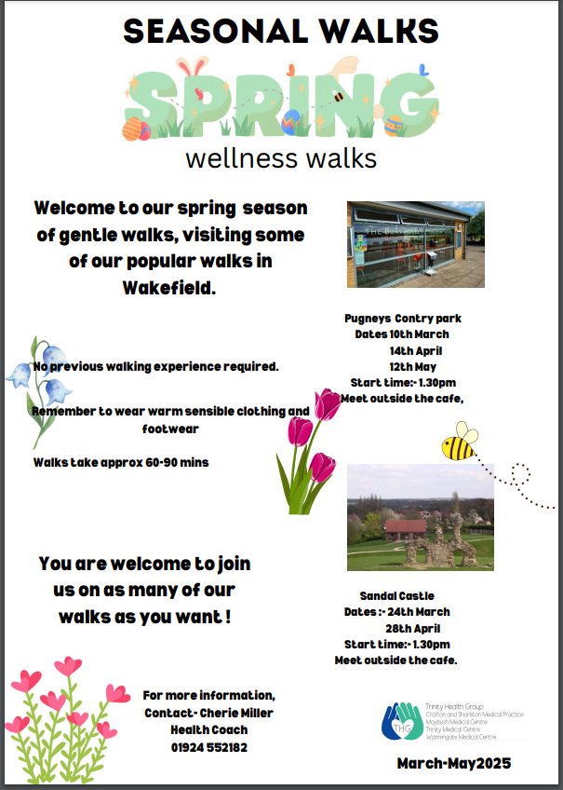

Summer Newsletter
The Summer Newsletter will be issued in June 2025
Please let us know if there is any information you would find useful or if you would like to know more about our services.

