

Warrengate Medical Centre – Spring Newsletter 2026
🌼 Welcome
Welcome to the Spring issue of our Practice Newsletter. Please inform a member of staff if you have suggestions for future editions.
🌼 Dates for Your Diary
• Wednesday 15th April – Close 12 noon, reopen 8.00am next day
• Wednesday 13th May – Close 12 noon, reopen 8.00am next day
• For medical emergencies please telephone NHS 111.
🌼 Upcoming Bank Holidays
• Friday 3rd April – Good Friday
• Monday 6th April – Bank Holiday
• Monday 4th May – Bank Holiday
• Monday 25th May – Bank Holiday
🌼 Spring into Summer!
Clocks go forward by 1 hour on Sunday 29th March 2026.
🌼 HPV Vaccines
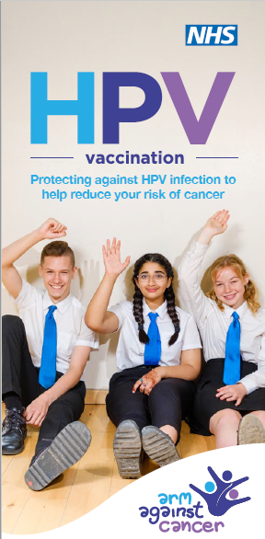
Protect yourself and your future with the HPV vaccine. Human Papillomavirus (HPV) is common and can cause several cancers; the vaccine helps protect you.
✔ Safe ✔ Effective ✔ Free on the NHS!
🌼 COVID-19 Vaccination Clinics – Spring 2026
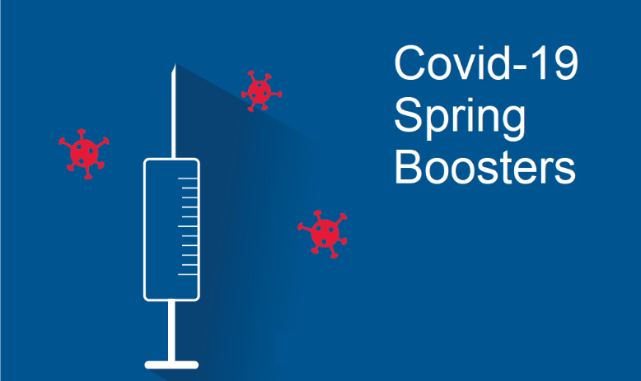
Warrengate will provide COVID-19 vaccinations directly at the Practice for the 2026 campaigns. Eligible groups include adults aged 75+, care home residents, and immunosuppressed patients. Spring campaign dates: 13 April 2026 – 30 June 2026.
🌼 Pharmacy First
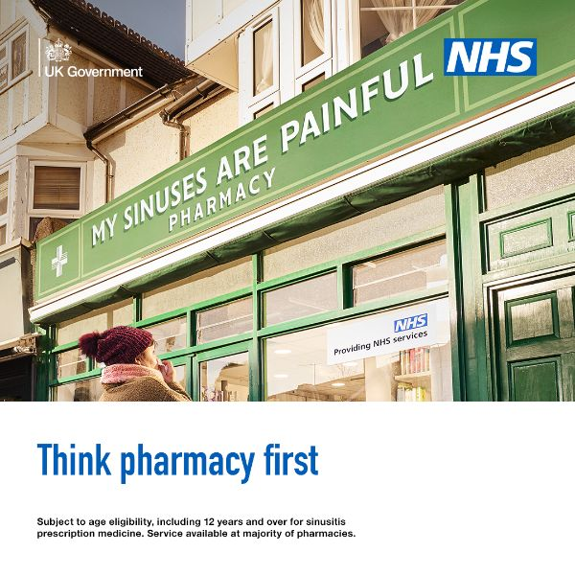
• Acute otitis media – 1–17 years
• Impetigo – 1+ years
• Infected insect bites – 1+ years
• Shingles – 18+ years
• Sinusitis – 12+ years
• Sore throat – 5+ years
• Uncomplicated urinary tract infections – Women 16–64 years
🌼 Armed Forces Veterans Support

We’re proud to be a Veteran Friendly Accredited GP practice and to support our veteran community. Our team understands the unique health needs that veterans may have and strives to provide the best care and support.
🌼 Baby News
Megan, our Practice Nurse, is now on maternity leave. We wish her and her family all the love and joy during this special time.
🌼 Eastmoor Community News
• Wakefield Citizens Advice – Free drop-in Tuesdays 10am–12pm
• Struggling with Bills or Food? Call 01924 361212
• Step Up Career Support – First Wednesday each month, 9am–5pm
• Café on the Moor – Monday–Friday, 9am–2pm
🌼 What’s Happening at Light Waves

Next Generation Saturday Youth Group – Ages 8–12 – £1 per session. Drinks, snacks, sports, games, crafts and creative activities.
Our Summer newsletter will be published June 2026.

